Summary of Result

# Questions

## **What is the correlation (R2 value) between sales and income?**

Sales and income are positively correlated. The correlation between sales and income is **0.78**. The following scatterplot chart presents the independent (income) and the dependent (sales) variable’s relationship. The trend line shows a positive correlation.

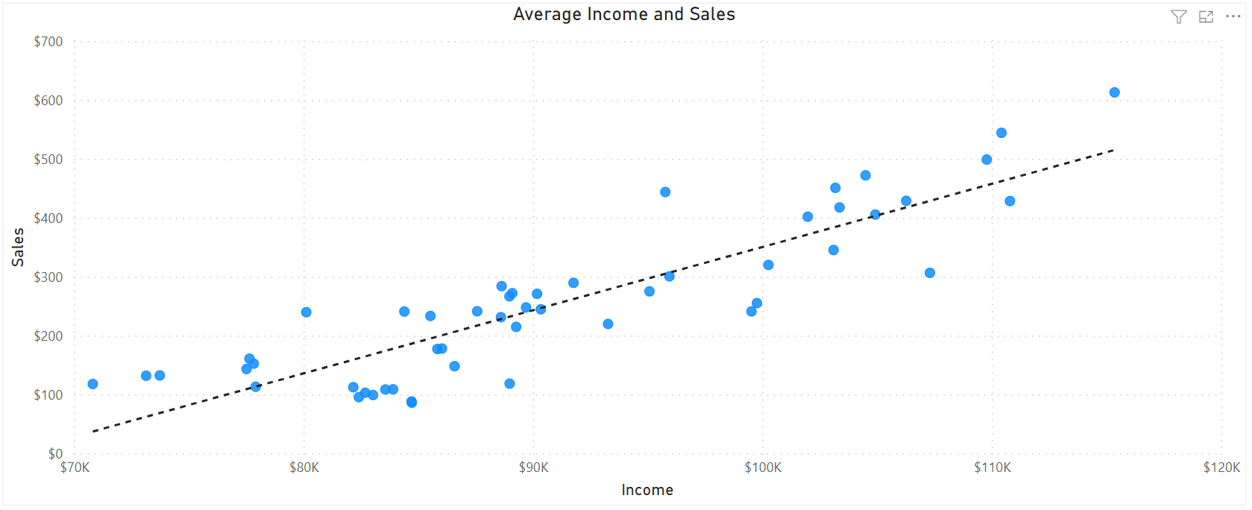

## **What is the correlation (R2 value) between customer ratings and product return rate?**

The customer rating and the return rate are negatively correlated. The correlation between the customer rating and the return rate is **0.69**. The following scatterplot chart presents the independent (return rate) and the dependent (customer rating) variable’s relationship. The trend line shows a negative correlation.

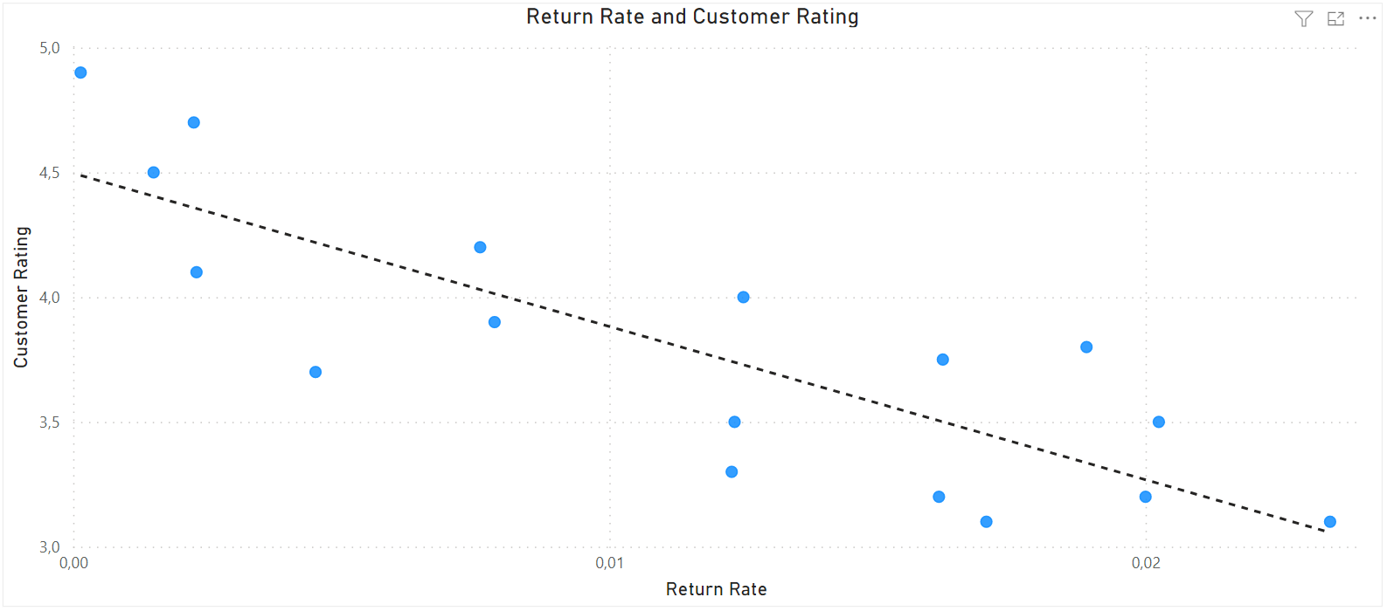

## **What are the linear regression formulas to predict customer income from customer sales?**

The formula to calculate customer sales: $y=0.01073x-722.14$

The formula to calculate customer income: $x= \frac{y+722.14}{0.01073}$

## **Which customer do you predict has the highest income?**

The customer with the highest predicted income is Jon Little. He is born 1984 June 3., and he is from Illinois. He purchased for $5250 in the last 6 months, and his predicted income is $556583.411.

## **Which product will be advertised the most?**

The most advertised product is going to be the sweater. It is recommended if the customer’s purchases (last 6 months) are more than $100 or less than $1000. The sweater will be advertised to 606 customers and the sweater’s price is $100. The estimated income from the sweaters are going to be from $60600.

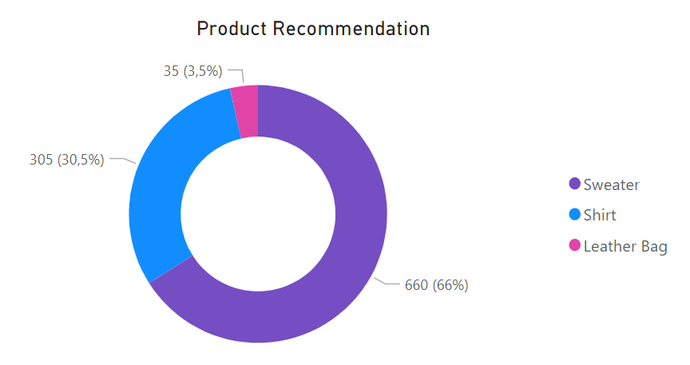

# Additional finding

The state of Illinois contains the maximum range of income. The product recommendation for Illinois will be the leather bag. The second largest income range is in New Jersey and the coat is going to be advertised here. Finally, the sneaker products will be recommended to the Californian customers.

